Year 2 Workshop Plan

Homework 2.A.4 - Money

Resources needed for this workshop
Approx. 1hr

For demonstration:  - Flip chart/interactive white board  - Enlarged OMP homework game  - Large demo counters  - Large 0-10 digit cards  - Marker/whiteboard pens/blu tack  - 2 large 1-6 dice  - Large demo coins  - Demo £ and . signs and money cards  - How much? picture cards | For each pair:  - Counters  - Pencil  - Paper  - Paper clip  - A3 copy of OMP game  - A4 copy of coin total sheets  - 2 x 1-6 dice  - 0-9 digit cards  - Plastic coins 1p,2p,5p,20p.50p  - Coin with head /tails on it /pair

General Introduction
Welcome to the Ocean maths workshop.
Start by talking a little about role as parents or carers. Research shows that parents who spend time showing an interest in their child’s learning playing games talking with them or just listening to them can really help their child’s learning.
You play a very important role in your child’s learning. Children learn in many different ways. Games are a good way to learn you don’t have to write things down as ‘sums’ all the time. Explain about the game in the middle. Ask for hands up of parents who do play the game at home. Stress importance of it and of supporting child to do their homework

Introduce the maths for the workshop (Objectives for teachers)
This homework is about money. Money is a very good area of maths for parents to support children with at home. The best way for children to get to understand money is to use it. It is very much a part of our every day lives. Being able to use money is a life skill. Talk about things to do to help children. Give example of playing a shopkeeper/customer game
Warm up Hold up some 1 and 2 digit numbers everyone call out what they are. Think of a shape e.g triangle, square, circle. Draw it on your partners back with your finger. Can they say which one you drew. Draw a number. Ask group to draw a number 10 in the air with their finger/nose/ear. Put fingers flat on table. Partner asks you to move each finger in turn, now tap it, bend it. Swap.
arm ups

Activity 1: Recognising coins
Recognising the coins. Have a box of large coins or the coins in an envelope. describe a coin and ask a child to guess which coin it is and come out and find it in the box/envelope.

Activity 2: How much? (I got some pictures from the internet for this and put possible prices on them. you can find some fun /relevant items and hold them up for pairs to estimate prices.)
Talk about how much things cost if they are cheap/expensive e.g. could I buy a packet of crisps with 1p? 2p? 50p?
Show pictures of different things how much do we think it might cost? (Just for fun)
e.g. heelies, cup of tea, car, bike

Activity 3: Higher/lower (Or you could do this with 2, 4, 6, 8 cards etc)
Have coins hidden in envelopes. Ask children to come to the front. Take out coins in turn without looking. Audience has to predict if it will be worth more or less. Put their hands on their heads for higher and on their noses for lower. Children stand in a line holding their coin until all are out (8 in total)
Can play this game at home with coins out of your pocket or purse.
When finished ask children to put themselves in order. Ask audience if they are right.

Activity 4: How many totals? (Coins in a bag) copy these sheets back to back
This activity is to do in pairs. How many different totals can you make using 10ps, 5ps, 2ps? Demonstrate using the big coins. Is 2p+5p the same as 5p+2p? Same total. How many different totals can you find? (6 totals altogether). Can either go onto or suggest at start for those who do 10p, 5p and 2p quickly to try with 50p, 20p and 10p coins. Again how many totals can you make?
Write them all down on your A4 sheet of paper.
NB to parents good to get across the point to children there is no 3p, 4p ,6p or 7p etc and that we can make those values using the other coins in different ways.

Activity 5: £ and p OMP Homework Game (I made some cards for this where I separated the £ and pence signs and showed how and when to use them e.g. when you use the £ sign we don’t need the p and demo this at front)
The game in the middle is all about adding pence and pounds together. Explain it is important that children understand that the point separates the pounds and the pence.
Show using large cards and blu tac them onto the board. Show how p disappears when you use the £ sign.
Each pair will need a real coin as the plastic coins don’t have heads and tails on them.
Explain how to play the game.
Explain what heads and tails is.

These are extra activities which you can do if you have time or can replace other ones. You may want to do more of a mixture of money and number.

Activity 6: Spider Spider

Need 2 dice/pair A4 paper and pencil
Aim is to be the first one to draw a complete spider.
Throw both dice

First you need to score 10 to draw a body
Then you need to score 8 to draw a head
You need to 5 to draw an eye (one at a time)
You need 7 to draw a leg
You must get the body first, then you can start collecting legs. But you can’t get the eyes until you have the head.

You need 1 body, 1 head, 2 eyes, and 8 legs in total.
Keep taking turns to throw until one of you has a complete spider.
You both need to draw your own spider
If somebody wins play again if you have time.

Activity: Making sums/number sentences (1-6 dice x2)
Throw the two dice and add the two numbers together. What are all the totals you can make?
Now try throwing the dice again and this time find the difference between the numbers. How many can you find?
You could take it in turns whoever makes the highest total scores a point. First one to reach 5 or10 is the winner.

Close
Thank you for coming, hope you have enjoyed working with your children, remember it is really important to help your child at home.
Have fun doing your homework!

NNS Links
- Recognise coins and notes of different values
- Recognise and appreciate the value of coins
- Find totals of coins
- Understand how we use £ sign and p sign and decimal point.
- Finding totals
- Giving change (from 20p)
- Writing amounts of money using £ and p

Vocabulary
Pounds, pence, decimal point, one, two, ten, twenty, fifty, cost,

How many totals can you make using
5p, 2p and 1p

 | + |  | =

 | + |  | =

 | + |  | =

 | + |  | =

 | + |  | =

 | + |  | =

What other totals can you make if you add 3 numbers together?
How many totals can you make using a
50p, 20p and 2p

+
+
=
+
+
=

+
+
=

+
+
=

+
+
=
+
+
=
+
+
=
+
+
=

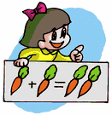
Money


Vocabulary
Pounds Pence
Coins Total cost
One Two
£ Decimal point

Walking to and from school
- Do not forget to count on in:- 1’s, 2’s, 5’s and 10’s.

- Do not forget to count back in:- 1’s, 2’s, 5’s and 10’s.

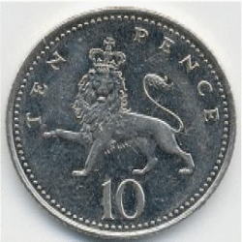
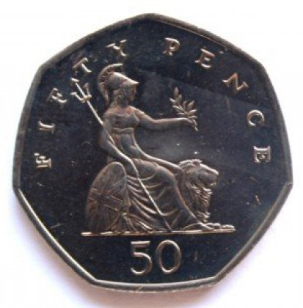
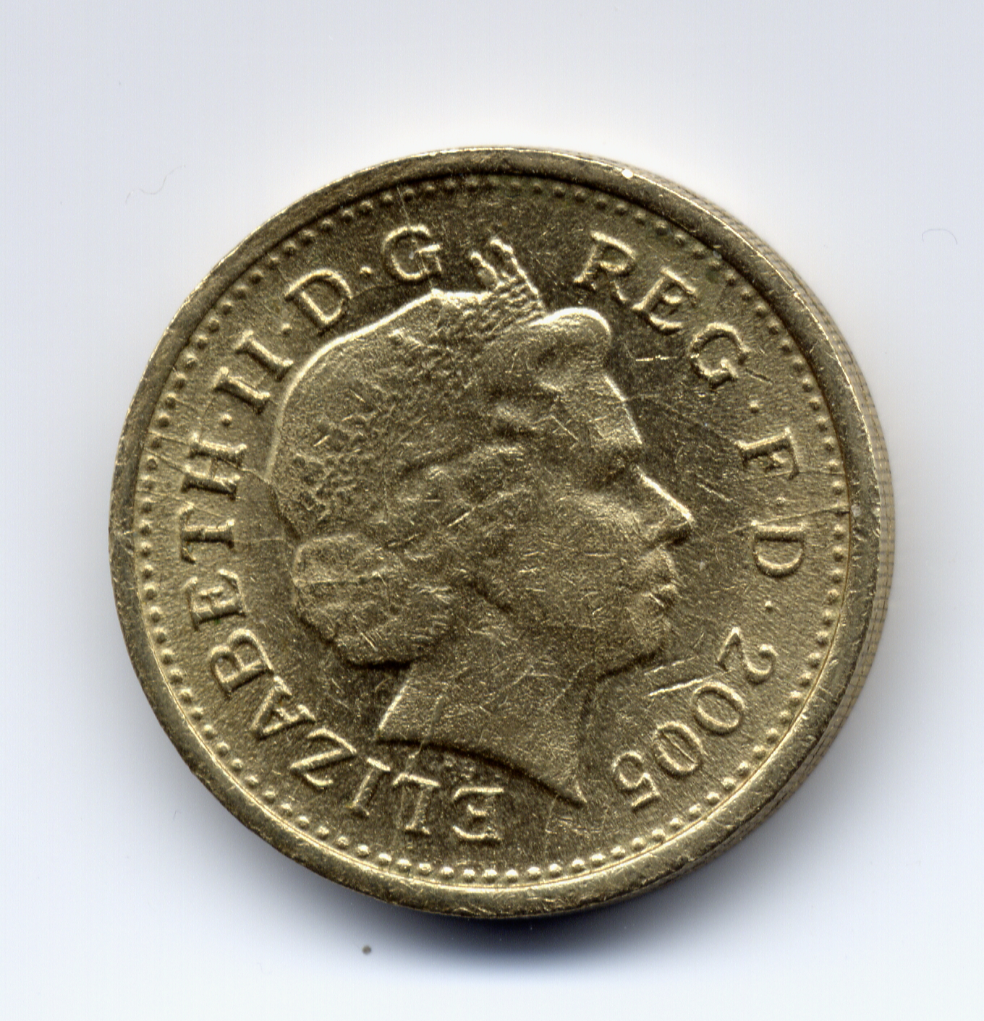
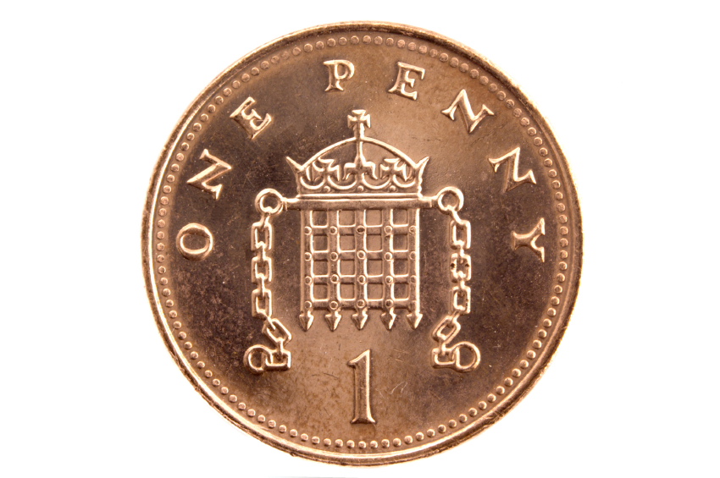
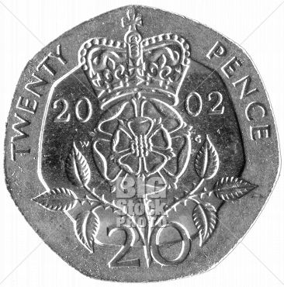

Games to play at home
- Let’s play shop keeper at home.
- Count the coins in your purse/ pocket
- Go to the shops give children money help them to work out the change
- Use of words such as cheap and or expensive
- Play higher or lower with coins in your purse e.g. take out one then ask if the next will be higher/lower
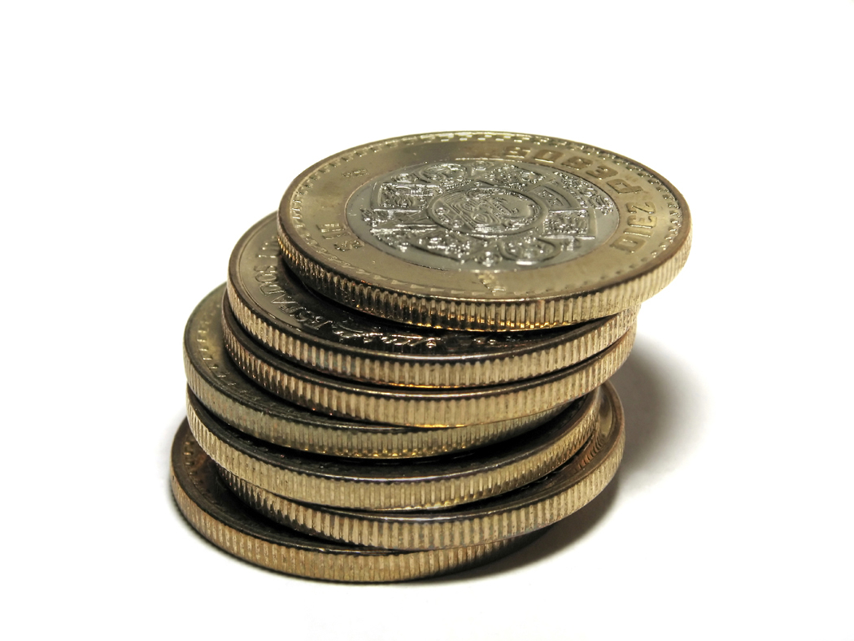
- Put price stickers around the house play games with money e.g. get me 3 items how much will it cost?

2A4

